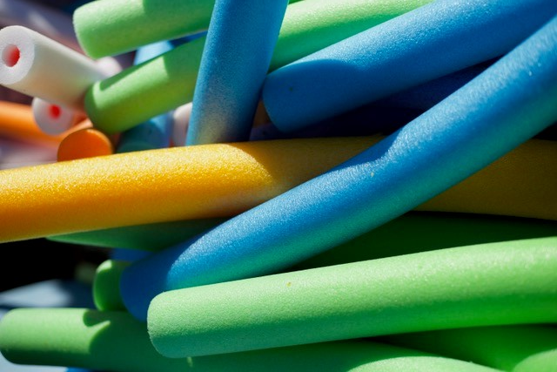
Video Links to Aqua Fitness Classes and Exercises
https://www.youtube.com/watch?v=OPhXxio3WMU. This video shows how to use a water noodle. Holding a noodle just under the surface of the water adds challenge for your core! When using a noodle, you should move at a pace that is comfortable.
https://www.youtube.com/watch?v=eTE2iKcISeU. Here is another video showing using a noodle to work your “abs”.
https://www.youtube.com/watch?v=4v88XbXpnGM&list=RDeTE2iKcISeU&index=2. This is a video called Shape Up with Pooja. It shows not what she is doing above the water, but also below the water. This aqua video provides routines for cardio, as well as arm strength and toning. Workout to get rid of love handles and flabby arms! This is also a great cardio routine!
https://www.youtube.com/watch?v=CQV9FlyIZRE&list=RDeTE2iKcISeU&index=2 . This video shows a fast-paced aqua aerobics class. This video shows exactly what is happening below the water too! Great up-beat class routine. Here is another one that is similar: This video offers some great ideas to use the next time you are in the pool.
https://www.youtube.com/watch?v=g5rhD69K7aY - Great for resistance work! Good for building up strength if someone has a mild injury in the shoulder or knee injury.
https://www.youtube.com/watch?v=g5rhD69K7aY - This workout uses Smart Bells in the water It is great for resistance work! It’s also good for building up strength if someone has a mild injury in the shoulder or knee injury. You can get an aerobic workout as well as a resistance workout. Want to try the Smart Bell – contact Kory Ward, SSW Club VP. See photo below.
